Database

These are the database tables in mysql workbench populated with raw data and there is relationship between these tables.

Class Group:

This is class group table where prog_code is the foreign key and has one to many relationship between class group table and program table.

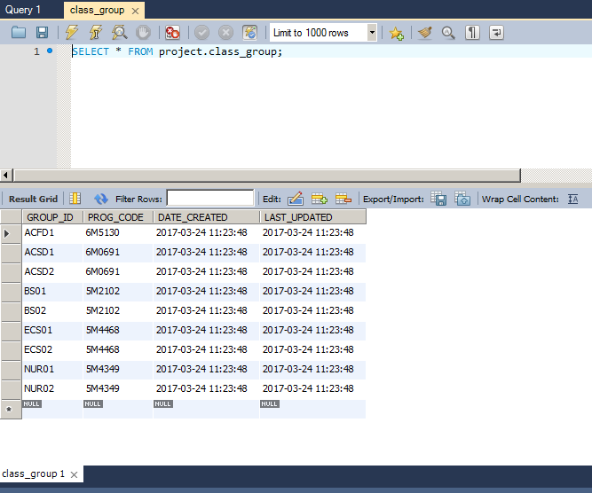

Module:

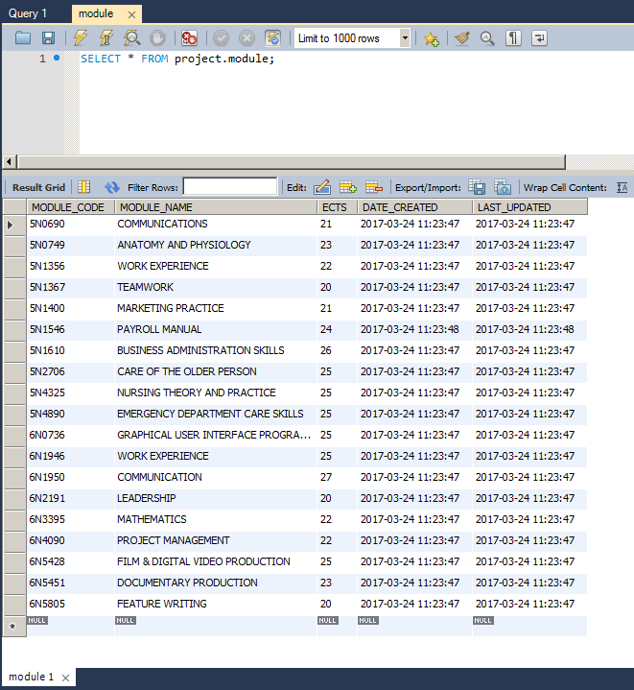

Program Module:

This is program module table which is intermediate table between module and program and shows the many to many relationship.

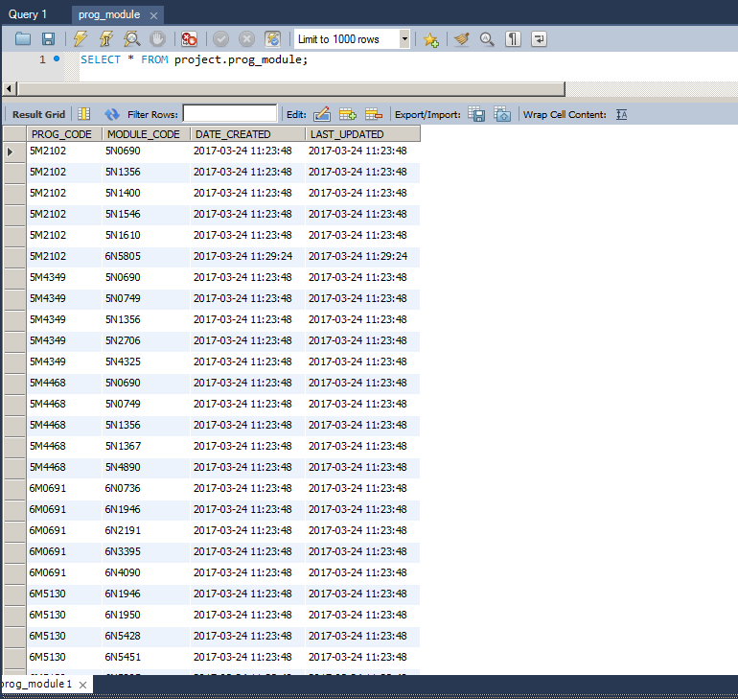

Program:

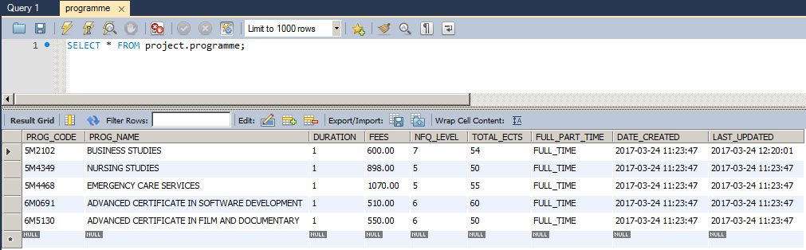

Students Results:

This is results table where module code and student id are foreign keys and work as many to many relationship.

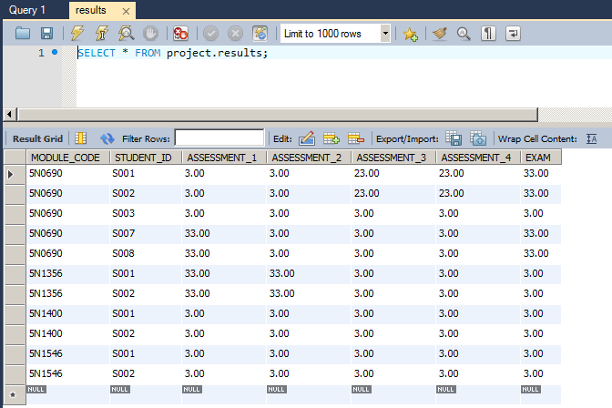

Student:

This is student table where group id is a foreign key and there is one to many relationship

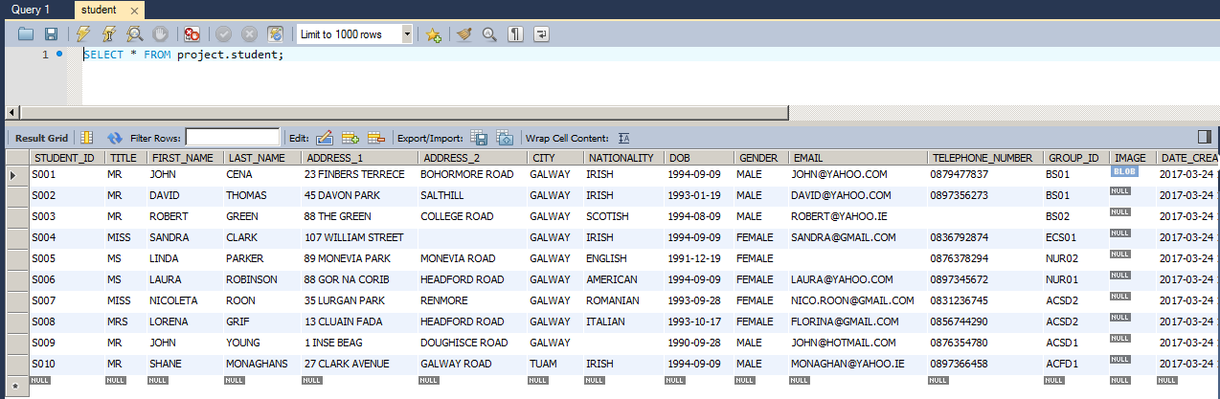

Teacher:

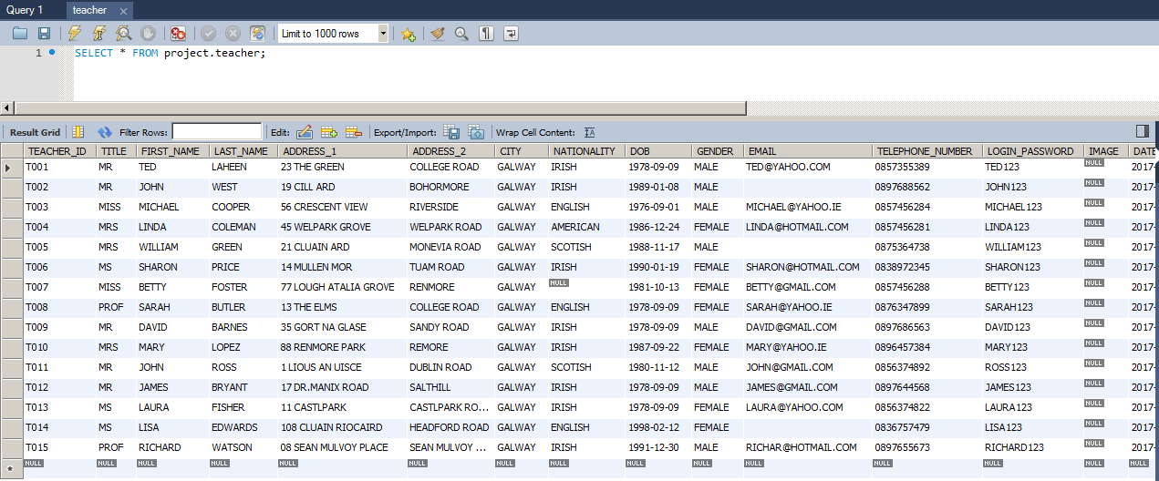

**Teacher teaches:**

This is teacher teaches table where module code group id and teachers Id are foreign key and there is many to many relationship.

